# PROJECT DESIGN PHASE – II

CLASSIFICATION TECHNIQUE

CLASSIFIER TO GET THE INPUT

**DATA FLOW DIAGRAMS AND USER STORIES**

|  |  |
| --- | --- |
| DATE | 22 November 2022 |
| TEAM ID | PNT2022TMID25156 |
| PROJECT NAME | STATISTICAL MACHINE LEARNING  APPROACHES TO LIVER DISEASE PREDICTION |
| MAXIMUM MARKS | 4 MARKS |

**DATAFLOW DIAGRAM**

LIVER DATASET

PRE-PROCESSING THE DATASET

TRAINING

TESTING

RANDOM FOREST

PREDICTION OF LIVER DISEASE

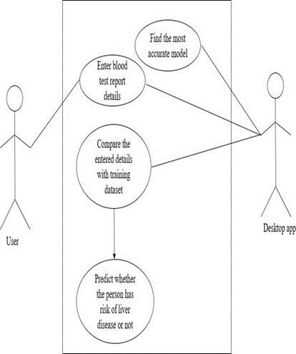

**USER STORY**

|  |  |  |  |  |  |  |
| --- | --- | --- | --- | --- | --- | --- |
| **User Type** | **Functional Requirement**  **(Epic)** | **User Story**  **Number** | **User Story / Task** | **Acceptance criteria** | **Priority** | **Release** |
| Customer (Web user) | Registration | USN-1 | As a user, I can register for the application by entering my email, password, and confirming my password. | I can access my account / dashboard | High | Sprint-1 |
|  | Login | USN-2 | As a user, I can log into the application by entering email & password | I can access my account / dashboard | Medium | Sprint-1 |
|  | Dashboard | USN-3 | In our dashboard it will display about the symptoms of the liver disease | User can know the details about the liver disease | Medium | Sprint-2 |
|  | Liver predication page | USN-4 | The user should enter the details of the parameter | Details of the parameter | Medium | Sprint-2 |